
DEBRE BERHAN UNIVERSITY
COLLEGE OF COMPUTING
DEPARTMENT OF COMPUTER SCIENCE
Project Title : AI-Integrated Construction Project and Resource Management System

Group member id
- Getahun Fikade ……………………………..…1501222
- Fikadu Asafaw…………………………………1501633
- Temesgen Birhanu………………………………1501496
- Abel Negash …………………………………….1404936

Submitted to Metadel.A
Submission data :10/10/18 E.C

ABSTRACT
The AI-Integrated Construction Project and Resource Management System is a web-based application developed to improve the management of construction projects, resources, procurement activities, and financial operations. The system integrates project management, employee management, material tracking, reporting, and financial monitoring into a single platform to enhance efficiency and coordination. It also incorporates Artificial Intelligence technologies to provide project cost prediction, delay prediction, resource optimization, and decision-support services. The system is designed using a three-tier architecture with secure data management and role-based access control to ensure reliability and security. By automating key construction management processes and providing intelligent insights, the proposed solution improves project performance, optimizes resource utilization, supports informed decision-making, and reduces delays and operational challenges in construction management.

ACKNOWLEDGMENT
We would like to express our sincere gratitude to God for granting us the strength, wisdom, and guidance to successfully complete this project. We are deeply thankful to our project advisor and instructors for their valuable guidance, constructive comments, continuous support, and encouragement throughout the project. We also extend our appreciation to the staff and personnel of the organization for providing the necessary information and data during the data collection process. Special thanks go to all respondents who participated in the interviews and generously shared their time, knowledge, and experiences, which greatly contributed to the success of this study. We would also like to thank our department, classmates, and friends for their cooperation and support. Finally, we are sincerely grateful to our families for their continuous encouragement, patience, understanding, and motivation throughout our academic journey. We appreciate everyone who contributed directly or indirectly to the successful completion of this project.

Chapter 1: Introduction 1
1.1 Background of the Project 1
1.2 Problems and Justifications 2
1.2.1 Problem Statement 2
1.2.2 Justification of the Project 3
1.3 Project Objectives 3
1.3.1 General Objective 3
1.3.2 Specific Objectives 3
1.4 Project Scope and Limitations 4
1.4.1 Project Scope 4
1.4.2 Project Limitations 7
1.5 Significance of the Project 8
Chapter Two Review of Related Work 11
2.1 Introduction 11
2.2 Construction Management Practices in Ethiopia 11
2.3 Manual Paper-Based Construction Management Systems 11
2.4 Semi-Digital Systems (Excel and Communication Tools) 12
2.5 Identified Gaps in Existing Practices 12
2.7 Conclusion 13
Chapter 3 Methodology 14
3.1 Overview of Selected Methodologies 14
3.2 Reasons for Selecting These Methodologies 14
3.3 Explanation of How the Chosen Methodology Supports the Proposed 15
3.4 Data Collection and Analysis Methods 16
3.4.1 Data Collection Tools and Techniques 16
3.5.4 Dynamic Modeling 25
3.5.5 User Interface Design 28
3.6 Development Approach 30
Chapter 4 Proposed System Requirements 31
4.1 Functional Requirements 31
4.2 Non-Functional Requirements 32
4.3 System Constraints 33
4.4 User Requirements 33
Chapter 5 System Analysis and Modeling 36
5.1 System Modeling 36
5.1.1 Scenarios 36
5.1.2 Use Case Modeling 38
5.1.3 Use Case Description 39
5.1.4 Object Modeling 40
5.1.4.1 Data Dictionary 40
5.1.4.2 Analysis Level Class Diagram (Conceptual Modeling) 41
5.2 Dynamic Modeling 43
5.2.1 Sequence Diagrams 43
5.2.2 Activity Diagrams 45
5.2.3 State Diagrams 46
5.2.4 User Interface 47
5.2.5 Supplementary Specifications Overview 48
CHAPTER 6 SYSTEM DESIGN 50
6.1 Introduction 50
6.2 System Architecture Design 50
6.3 Database Design 51
6.3.1 Database Entities 51
6.3.2 Entity Relationship Diagram (ERD) 52
6.4 User Interface Design 53
6.5 Component Design 55
6.6 Class and Object Design 56
6.6.1 Introduction 56
6.6.2 Major Classes 56
6.6.3 Class Relationships 56
6.7 Security Design 57
6.7.1 Introduction 57
6.7.2 Authentication 58
6.7.3 Authorization 58
6.7.4 Data Security 58
6.7.5 Backup and Recovery 58
6.7.6 Audit and Monitoring 58
6.8 System Integration Design 58
References 60

List of figures
Figure 5.1 use case diagram ………………………………………………………39
Figure 5.2 sequence diagram for project management ………………………….. 43
Figure 5.3 sequence diagram for material request ……………………………....44
Figure 5.4 activity diagram ……………………………………………………….45
Figure 5.5 state diagram……………………………………………………………46
Figure 6.1 archtecture diagram ……………………………………….…………50
Figure 6.2 ER diagram ………………………………………………….……….52
Figure 6.3 home user interface …………………………………………………..53
Figure 6.4 admin dashboard interface ……………………………………………54
Figure 6.5 class diagram…………………………………………………………. 56
Figure 6.6 Integration diagram ……………………………………………………58

Chapter 1: Introduction

Background of the Project
The construction industry is one of the most important sectors contributing to economic growth and infrastructure development in Ethiopia. Construction companies are involved in building residential apartments, commercial buildings, schools, hospitals, roads, and other public infrastructures. Managing construction projects requires efficient coordination of workers, materials, suppliers, expenses, and project schedules.
Despite the growth of the construction sector in Ethiopia, many construction companies still rely on manual and traditional management methods. Worker attendance is often recorded using notebooks, material inventory is tracked manually, supplier communication is conducted through phone calls, and project expenses are documented using paper-based records or simple spreadsheets. These manual processes are time-consuming, prone to human error, and make it difficult for managers to access real-time information.
As construction projects become larger and more complex, manual management creates several challenges, including poor workforce coordination, material shortages, budget overruns, project delays, and lack of visibility into project progress. Furthermore, most companies do not utilize historical project data to support decision-making, making it difficult to predict future costs, resource requirements, or potential delays.
Recent advancements in web technologies and Artificial Intelligence (AI) provide opportunities to improve construction management practices. AI can analyze project data, predict project costs, forecast material requirements, detect delay risks, and recommend resource allocation strategies.
Therefore, this project proposes the development of an AI-Integrated Construction Project and Resource Management System that digitizes project management, worker management, material management, supplier management, expense tracking, and reporting processes. The system aims to improve efficiency, transparency, decision-making, and overall project performance in Ethiopian construction companies.

Problems and Justifications
    - Problem Statement
Currently, many construction companies in Ethiopia face significant operational challenges due to the use of manual and fragmented management systems.
Manual Record Keeping
Worker information, attendance records, material inventories, and expenses are commonly maintained using notebooks, paper documents, or spreadsheets. This
approach increases the risk of data loss, duplication, and human errors.
Poor Material Management
Construction materials such as cement, steel, sand, and aggregates are often tracked manually. As a result, companies experience material shortages, overstocking, wastage, and difficulties in monitoring inventory levels.
Weak Workforce Management
Many companies lack a centralized system for managing workers. Attendance tracking, task assignment, and productivity monitoring are performed manually, making it difficult to evaluate workforce performance and resource utilization.
Inefficient Supplier Coordination
Material orders are frequently placed through phone calls or informal communication channels. There is often no proper mechanism for tracking supplier orders, delivery schedules, or supplier performance.
Lack of Cost and Budget Control
Project expenses are usually recorded manually, making it difficult to compare actual spending against planned budgets. This often contributes to budget overruns and financial inefficiencies.
Limited Project Visibility
Managers are unable to monitor project progress in real time. Project delays are often identified late, reducing the ability to take corrective actions promptly.
Absence of Data-Driven Decision Making
Most construction companies do not utilize project data for predictive analysis. Consequently, they cannot accurately forecast project costs, material requirements, workforce needs, or delay risks.
1.2.2 Justification of the Project
The proposed AI-Integrated Construction Project and Resource Management System is designed to address the limitations of existing manual systems by providing a centralized digital platform for managing construction operations.
The system will:
    - Digitize project management processes.
    - Improve worker attendance and task management.
    - Provide real-time material inventory tracking.
    - Streamline supplier management and order tracking.
    - Enable accurate expense and budget monitoring.
    - Provide dashboards and reports for managers.
    - Utilize Artificial Intelligence to predict project costs.
    - Forecast material requirements based on historical usage.
    - Detect potential project delays at an early stage.
    - Generate recommendations for workforce and resource allocation.
The proposed system will help construction companies improve operational efficiency, reduce project delays, minimize material wastage, enhance transparency, and support data-driven decision-making. As a result, the system can contribute to better project performance and more effective resource management within the Ethiopian construction industry.

1.3 Project Objectives

1.3.1 General Objective
To design and develop an AI-Integrated Construction Project and Resource Management System for construction companies in Ethiopia.

1.3.2 Specific Objectives
- To investigate the existing construction project management practices in Ethiopian construction companies.
- To identify and analyze the challenges associated with manual construction project and resource management systems.
- To gather and analyze the functional and non-functional requirements of the proposed system.
- To design the overall architecture of the AI-Integrated Construction Project and Resource Management System.
- To design a centralized database for managing project, worker, material, supplier, and financial information.
- To develop a project management module for project creation, planning, scheduling, and progress tracking.
- To develop a worker management module for worker registration, assignment, attendance recording, and productivity monitoring.
- To develop a material management module for inventory tracking, material allocation, and stock monitoring.
- To develop a supplier management module for supplier registration, order management, and delivery tracking.
- To develop an expense and budget management module for recording project expenditures and monitoring budget utilization.
- To develop a dashboard and reporting module for real-time monitoring and visualization of project performance.
- To integrate Artificial Intelligence techniques for project cost prediction and delay prediction.
- To implement a recommendation engine for resource allocation and project performance improvement.
- To test and evaluate the developed system to ensure its functionality, usability, reliability, and performance.

1.4 Project Scope and Limitations
1.4.1 Project Scope
The proposed project focuses on the design and development of an AI-Integrated Construction Project and Resource Management System for construction companies in Ethiopia. The system aims to digitize and automate construction project operations by replacing manual and paper-based management practices with a centralized web-based platform. The system is intended to improve project monitoring, resource utilization, cost control, operational efficiency, and managerial decision-making.
The project covers the management of construction projects, workforce activities, construction materials, supplier records, project expenses, budgeting processes, and reporting mechanisms. The system will integrate Artificial Intelligence techniques to support project cost prediction, delay prediction, resource analysis, and intelligent recommendations.
The scope of the project includes the following functional areas:

- Project Management
- Creation and management of construction projects.
- Project planning and scheduling.
- Milestone and timeline management.
- Monitoring project progress and performance.
- Generation of project status reports.
- Workforce Management
- Registration and management of worker information.
- Assignment of workers to construction projects.
- Assignment of workers to specific construction tasks.
- Attendance recording and monitoring.
- Workforce productivity and performance tracking.
- Material Management
- Registration and management of construction materials.
- Inventory and stock management.
- Material allocation and usage tracking.
- Monitoring material availability.
- Generation of low-stock alerts and inventory reports.
- Supplier Management
- The proposed system does not provide direct access for suppliers to use the system.
- Instead, it focuses on internal supplier record management and procurement tracking.
- The supplier management functionality includes:
- Maintaining supplier information and contact details.
- Recording material purchase requests and orders.
- Tracking order status such as Pending, Approved, Ordered, Delivered, and Cancelled.
- Recording material delivery information.
- Maintaining supplier transaction history.
- Monitoring supplier reliability and delivery performance.
- Generating supplier-related reports.
- Expense and Budget Management
- Recording project expenses.
- Tracking labor, material, and operational costs.
- Budget planning and monitoring.
- Comparing actual expenditures against planned budgets.
- Generating financial reports and summaries.
- Dashboard and Reporting
- Real-time project monitoring and visualization.
- Resource utilization reporting.
- Material and inventory reporting.
- Financial and budget reports.
- Construction performance reports.
- Artificial Intelligence Integration
The system incorporates Artificial Intelligence components to support decision-making and project management activities.
The AI functionalities include:
- Project cost prediction using historical and current project data.
- Project delay prediction based on project progress and timelines.
- Resource utilization analysis.
- Recommendation generation for workforce and resource allocation.
- Project performance analysis and reporting.
Project Category
The proposed project falls under the following categories:
- Web-Based Application Development
- Full-Stack Software Development
- Management Information System
- Artificial Intelligence Integrated System
- Construction Resource Management System
Stakeholders of the Project
The major stakeholders of the project include:
- Construction company management.
- Project managers.
- Site engineers.
- Construction supervisors.
- Store and inventory personnel.
- Finance and accounting personnel.
Technologies and Tools
The project will utilize the following technologies and tools:
Frontend Technologies
- React.js
- Tailwind CSS
- JavaScript
Backend Technologies
- Node.js(Express.js)/laravel
Database
postgress
Artificial Intelligence Technologies
- Python
- Scikit-Learn
- Pandas
- NumPy
Development and Testing Tools
- Visual Studio Code
- Git and GitHub
- Postman
- Draw.io
- Figma
Methods to be Used
The project will follow the Software Development Life Cycle (SDLC) and will involve the following activities:
- Requirement gathering and analysis.
- System design and architecture design.
- Database design.
- Frontend and backend development.
- AI model development and integration.
- System testing and evaluation.
- Documentation and deployment preparation.
Expected Deliverables
The project will produce the following deliverables:
- Requirement Specification Document.
- System Design Document.
- Database Design and ER Diagram.
- AI-Integrated Construction Project and Resource Management System.
- Artificial Intelligence Prediction Models.
- Testing and Evaluation Report.
- User Manual.
- Technical Documentation.
- Final Project Report.
1.4.2 Project Limitations
Although the proposed system is designed to improve construction project and resource management, several limitations exist.
- The system is specifically designed for construction companies operating in Ethiopia and may require modifications for use in different countries or industries.
- The system is web-based and therefore requires internet connectivity for full functionality.
- The accuracy of AI predictions depends on the availability, quality, and quantity of project data used for analysis and model training.
- The Artificial Intelligence component is limited to cost prediction, delay prediction, resource analysis, and recommendation generation.
- The system does not provide direct access or login functionality for external suppliers.
- The system does not support Building Information Modeling (BIM) integration.
- The system does not include advanced equipment maintenance and machinery management features.
- The project focuses on web-based implementation and does not include dedicated mobile applications.
- Integration with government systems, banking systems, taxation systems, and third-party enterprise software is outside the scope of the project.
- Time, budget, and resource constraints associated with undergraduate projects may limit the implementation of some advanced enterprise-level features.
- Despite these limitations, the proposed system provides a practical and effective solution for improving construction project and resource management within Ethiopian construction companies.

1.5 Significance of the Project
The Construction and Worker Management System is highly significant in
improving the way construction companies manage their daily operations. In many construction organizations, traditional methods such as paper-based records and spreadsheet systems are still widely used. These approaches often result in inefficiencies, data inconsistency, miscommunication, and delays in project execution. This project introduces a centralized and digital solution that enhances accuracy, transparency, and efficiency in managing construction-related activities such as project management, workforce control, material handling, cost tracking, and supplier coordination.
Academic Significance
From an academic perspective, this project demonstrates the practical application of full-stack web development technologies such as React, Node.js, and MySQL in solving real-world problems. It integrates important concepts from software engineering, database design, system analysis, and web application development. The project also strengthens problem-solving and system design skills while providing a practical reference for future students who are interested in developing similar enterprise-level systems, especially in construction management and resource tracking domains.
Industry Significance
In the construction industry, the system provides a modern and efficient platform for managing key operational activities. It supports project planning, worker management, material tracking, cost control, and supplier coordination in a unified system. By digitizing these processes, construction companies can monitor project progress in real time, reduce material wastage, minimize financial errors, and improve communication between all stakeholders. This leads to better decision-making, increased productivity, and timely completion of construction projects within budget.
Societal Significance
From a societal perspective, the system indirectly contributes to improved infrastructure development by enhancing the efficiency of construction projects such as roads, buildings, and public facilities. When construction activities are well-managed and completed on time, society benefits through improved access to essential infrastructure services. Additionally, the project supports digital transformation in traditional industries in Ethiopia by encouraging the adoption of modern technologies in construction and related sectors.
Primary Beneficiaries
The system serves multiple stakeholders involved in the construction lifecycle, each benefiting in different ways according to their roles.
Construction company managers and administrators benefit from a centralized dashboard that provides real-time visibility of projects, budgets, resource allocation, and overall performance. This enables them to make informed decisions and maintain better control over construction operations.
Site engineers and project supervisors benefit from improved monitoring and coordination tools that help them track daily progress, assign tasks, and ensure that construction activities are carried out according to plan and technical standards.
Workers and labor coordinators benefit from improved task organization and workforce scheduling, which reduces confusion, enhances communication, and increases productivity at construction sites.
Suppliers and material vendors benefit from a streamlined procurement process where material requests, orders, and deliveries are efficiently tracked, reducing delays and improving supply chain coordination.
Clients and property developers benefit from increased transparency in project progress, timelines, and cost updates, allowing them to stay informed and confident about project delivery.
The general public benefits indirectly from improved infrastructure development, as more efficient construction processes lead to timely completion of roads, buildings, and public facilities, ultimately improving living standards and supporting economic growth.
Overall Contribution
Overall, the system enhances efficiency, transparency, and coordination among all stakeholders in the construction industry. It reduces manual workload, minimizes errors, and introduces a scalable digital solution that can be further extended with advanced features such as mobile access, real-time analytics, automated reporting, and predictive project management in future developments.

Chapter Two Review of Related Work

2.1 Introduction
This chapter reviews existing approaches and practices related to construction project
management and worker management systems. The purpose of this review is to understand how construction activities are currently handled in real-world environments, particularly in the Ethiopian construction industry context. It also identifies the strengths and limitations of existing manual and semi-digital approaches in terms of features, requirements, tools, methods, and system organization. This analysis helps to justify the development of the proposed Construction and Worker
Management System.

2.2 Construction Management Practices in Ethiopia
In Ethiopia, many construction companies still rely on traditional and semi-digital
methods to manage projects, workers, materials, and costs. These methods are mainly based on manual paperwork, Excel spreadsheets, and informal communication tools such as phone calls and messaging applications.
In most cases, project progress reports are written manually and submitted physically from site engineers to project managers. Worker attendance and assignments are often recorded on paper, while material requests and supplier communication are handled through phone calls or informal messages. Although these methods are widely used due to their simplicity and low cost, they lack integration, automation, and real-time
data sharing capabilities.

2.3 Manual Paper-Based Construction Management Systems
Manual systems are the most common approach used in small and medium
construction companies in Ethiopia.
Features:
- Paper-based recording of workers, materials, and project progress
- Physical documentation of reports and approvals
- Face-to-face or phone-based communication
- Manual calculation of costs and budgets
Strengths:
- Easy to use without technical knowledge
- No need for internet or software infrastructure
- Low implementation cost
- Suitable for very small projects
Limitations:
- High risk of data loss and damage
- Difficult to track project progress in real time
- Slow communication between stakeholders
- Inefficient storage and retrieval of records
- Prone to human error in calculations and reporting

2.4 Semi-Digital Systems (Excel and Communication Tools)
Some construction companies use basic digital tools such as Microsoft Excel, Word
documents, and messaging applications like WhatsApp to manage construction activities.
Features:
- Digital documentation of reports
- Communication through messaging applications
- Basic data organization using files and folders
- Spreadsheet-based cost and material tracking
Strengths:
- Better organization compared to paper-based systems
- Easy to edit and share files
- Basic data storage and calculation capability
- Low cost and widely available tool
Limitations:
- Lack of centralized database system
- No real-time synchronization between users
- Data duplication and inconsistency issues
- Limited collaboration and workflow automation
- No integrated system for workers, materials, and project tracking

2.5 Identified Gaps in Existing Practices
Based on the analysis of manual and semi-digital systems, several key gaps have been
identified in the Ethiopian construction industry:
- Lack of centralized system for managing all construction activities
- No real-time tracking of project progress, materials, and workers
- Heavy reliance on manual communication methods
- Inefficient coordination between site engineers, managers, and suppliers
- Poor data accuracy due to manual entry and duplication
- Lack of automation in reporting and decision-making processes
These gaps clearly show that existing practices are not sufficient to support efficient and modern construction management, especially for medium and large-scale projects.
2.6 Proposed System Justification
The proposed Construction and Worker Management System is designed to address the limitations identified in existing practices. It introduces a centralized web-based platform that integrates project management, worker management, material tracking, supplier coordination, and cost management into a single system.
Unlike manual and semi-digital approaches, the proposed system ensures that all data is stored in a centralized database and can be accessed in real time by authorized users. This improves communication, reduces redundancy, and enhances decision-making efficiency.
The system is developed using modern technologies such as React for the frontend, Node.js for backend services, and MySQL for database management. These technologies provide scalability, reliability, and flexibility, making the system suitable
for real-world construction environments in Ethiopia.

2.7 Conclusion
This chapter reviewed existing construction management practices in Ethiopia,
focusing on manual and semi-digital systems commonly used in the industry. The analysis revealed that although these methods are simple and cost-effective, they suffer from major limitations such as lack of integration, poor data management, and delayed communication.
The identified gaps strongly justify the need for a modern, centralized, and automated Construction and Worker Management System. The proposed system aims to improve efficiency, transparency, and coordination among all stakeholders in the construction industry.

Chapter 3 Methodology

3.1 Overview of Selected Methodologies
The development of the proposed AI-Integrated Construction Project and Resource
management System will follow the Agile Software Development Methodology using the Scrum approach. Agile is an iterative and incremental software development methodology that emphasizes flexibility, continuous improvement, teamwork, and frequent delivery of functional system components.
The Agile methodology divides the project into smaller development phases called iterations or sprints. During each sprint, specific system features are designed, developed, tested, and reviewed. This approach allows the development team to continuously evaluate progress, incorporate feedback, and make improvements throughout the project life-cycle.
The proposed system consists of several modules including Project Management, Worker Management, Material Management, Supplier Management, Expense and Budget Management, Dashboard and Reporting, and Artificial Intelligence Integration. These modules can be developed incrementally through multiple Agile development iterations.
The Scrum framework will be used to organize project activities, assign tasks among
team members, monitor progress, and ensure timely completion of project objectives.

3.2 Reasons for Selecting These Methodologies
The Agile Software Development Methodology was selected for the proposed project for several reasons.
Flexibility
The requirements of construction management systems may evolve during the development process. Agile allows modifications and improvements to be incorporated without significantly affecting the overall project development.
Incremental Development
The proposed system contains multiple modules such as workforce management, project management, inventory management, supplier management, and Artificial Intelligence integration. Agile enables these modules to be developed and tested independently in small increments.
Continuous Feedback
Agile supports regular feedback from project advisors, instructors, and potential users. This helps ensure that the developed system satisfies user requirements and project objectives.
Improved Team Collaboration
Since the project is developed by a team, Agile promotes communication, task sharing, collaboration, and responsibility among team members throughout the development process.
Early Detection of Problems
Frequent testing and review activities allow errors and design issues to be identified and corrected at early stages of development, reducing project risks.
Better Quality Software
The iterative nature of Agile supports continuous testing, refinement, and improvement of the system, resulting in higher software quality and reliability.
Suitable for AI Integration
The project incorporates Artificial Intelligence features such as cost prediction, delay prediction, resource analysis, and recommendation generation. Agile provides flexibility for experimenting, testing, and improving AI models throughout the
development process.

3.3 Explanation of How the Chosen Methodology Supports the Proposed
Project Objectives
The Agile Software Development Methodology directly supports the achievement of the project's objectives by enabling the development team to implement the system incrementally and efficiently.
The first objective of investigating existing construction management practices and identifying current challenges will be supported through requirement gathering and continuous stakeholder feedback during Agile iterations.
The objective of analyzing system requirements will be achieved through regular discussions, requirement refinement, and sprint planning activities.
The objective of designing the system architecture and database structure will be accomplished during the early development iterations, providing a strong foundation for subsequent implementation activities.
The development of the Project Management Module, Worker Management Module, Material Management Module, Supplier Management Module, and Expense and Budget Management Module will be carried out in separate Agile sprints, allowing each module to be developed, tested, and improved independently.
The Artificial Intelligence components, including project cost prediction, delay prediction, resource analysis, and recommendation generation, will be developed and integrated gradually through multiple iterations. This enables continuous evaluation and improvement of AI model performance.
The Dashboard and Reporting Module will be developed incrementally to provide real-time project monitoring and management capabilities.
Continuous testing and evaluation activities performed throughout Agile development cycles will support the objective of ensuring system functionality, usability, reliability, and performance.
Furthermore, Agile facilitates effective collaboration among team members responsible for frontend development, backend development, database design, and Artificial Intelligence implementation, thereby improving productivity and ensuring successful completion of the project within the available timeframe.
Overall, the Agile Software Development Methodology provides a flexible, collaborative, and efficient framework that supports the successful design, development, testing, and deployment of the proposed AI-Integrated Construction Project and Resource Management System while ensuring that all project objectives are effectively achieved.

3.4 Data Collection and Analysis Methods
3.4.1 Data Collection Tools and Techniques
The data required for the project were collected using both primary and secondary data collection methods.
A. Interviews and Phone Calls
Interviews and phone call discussions were conducted primarily with Site Engineers working in the construction sector to gather information about current construction management practices, challenges, and operational workflows. Site Engineers were selected because they are directly involved in project execution, worker supervision, material usage monitoring, project progress tracking, and day-to-day construction activities.
The discussions focused on understanding:
- Current project management practices
- Worker management and attendance recording procedures
- Material request and usage processes
- Communication and coordination among project stakeholders
- Common challenges faced in construction projects
- Limitations of existing manual systems
- Requirements for an effective digital construction management system
The information obtained from Site Engineers provided valuable insights into the real-world operations of construction projects and helped identify key system requirements for the proposed solution.
B. Observation
Observation was used to understand how construction activities and resource management processes are performed in practice. Existing workflows and operational procedures were studied to gain a better understanding of construction project execution and resource utilization.
The observation focused on:
- Worker attendance management practices
- Material storage and inventory management activities
- Material request and procurement procedures
- Project progress monitoring activities
- Manual record-keeping and reporting methods
Observation helped validate information obtained from interviews and
provided a practical understanding of the daily activities performed on construction sites.
C. Literature Review and Online Resources
Secondary data were collected from various academic and professional sources to gain additional knowledge about construction management systems, project management practices, resource management techniques, and Artificial Intelligence applications in construction projects.
The reviewed sources included:
- Research papers
- Academic journals
- Books
- Conference proceedings
- Technical articles
- Industry reports
- Online resources and professional publications
- Related software systems and case studies
The literature review provided theoretical and technical foundations for the proposed system and helped identify best practices and modern technologies applicable to construction project management.
3.4.2 Analysis Tools and Techniques
After data collection, the gathered information was analyzed using various analysis tools and techniques to identify system requirements and design the proposed solution.
A. Requirement Analysis
Requirement analysis was conducted to identify and classify the functional and non-functional requirements of the proposed system.
- Functional Requirements
The functional requirements define the services and operations that the system must provide, including:
- Project management
- Worker management
- Material management
- Expense and budget management
- Dashboard and reporting functionalities
- AI-based prediction and recommendation features
- Non-Functional Requirements
The non-functional requirements define the quality attributes of the system, including:
- Security
- Reliability
- Performance
- Scalability
- Usability
- Maintainability
- Business Process Analysis
Business process analysis was used to understand the existing workflows followed in construction projects and identify inefficiencies in manual operations.
The analysis focused on:
- Project planning and monitoring processes
- Workforce management activities
- Material procurement and inventory management procedures
- Supplier coordination practices
- Expense tracking and budget monitoring activities
This analysis helped define improved workflows and system functionalities for the proposed solution.
- Unified Modeling Language (UML)
Unified Modeling Language (UML) was used to model and visualize the structure and behavior of the proposed system.
The UML diagrams developed for the project include:
- Use Case Diagrams
- Activity Diagrams
- Sequence Diagrams
- Class Diagrams
These diagrams help represent system functionalities, user interactions, and system architecture in a clear and organized manner.
D. Database Analysis and Design
Database analysis techniques were applied to identify system entities, attributes, and relationships necessary for storing and managing project information.
The database design process included:
- Entity identification
- Relationship analysis
- Entity Relationship Diagram (ERD) development
- Database normalization
This process ensures efficient data storage, consistency, and integrity throughout the system.
E. Artificial Intelligence Data Analysis
Data analysis techniques were used to prepare project-related data for Artificial Intelligence integration. The collected data were analyzed and organized to support the development of intelligent system features.
The analysis process included:
- Data cleaning
- Data preparation
- Feature selection
- Model training and evaluation
The analyzed data will be used to implement:
- Project Cost Prediction
- Project Delay Prediction
- Resource Analysis
- Recommendation Generation
- Software Development and Testing Tools
Various software development and testing tools will be used during the implementation of the proposed system.
These tools include:
- React.js for frontend development
- Node.js and Express.js for backend development
- posgress or monngo db for database management
- Python for Artificial Intelligence integration
- Visual Studio Code as the development environment
- Git and GitHub for version control and collaboration
- Postman for API testing
3.5 Design
The design phase of the proposed AI-Integrated Construction Project and Resource Management System focuses on transforming the identified requirements into a structured system architecture that supports efficient project management, workforce management, material management, supplier management, expense tracking, and intelligent decision-making.
The design process involves both logical and physical design approaches to ensure that the system is functionally effective, scalable, maintainable, and capable of supporting future enhancements.
3.5.1 Introduction to Design (Logical and Physical Design) Approaches
A. Logical Design
Logical design focuses on describing how the system functions from the user's perspective without considering the underlying hardware or implementation details. it consists of the following major modules:
Project Management Module
This module enables project planning, project creation, milestone management, task monitoring, and project progress tracking.
Responsible Users:
- General Manager
- Project Manager
- Site Engineer
Functions:
- Create projects
- Assign Project Managers
- Define project schedules
- Monitor project progress
- Generate project reports
Worker Management Module
This module manages workforce information, attendance records, worker allocation, and labor cost monitoring.
Responsible Users: HR Manager and Site Engineer
Functions:
- Register workers
- Manage worker profiles
- Assign workers to projects
- Calculate labor costs
- Track worker contracts
- Material and Supplier Management Module
This module manages inventory, material requests, supplier information, procurement activities, and material transfers between stores and project sites.
Responsible Users:
Procurement Officer (Store Keeper) ,Site Engineer and Project Manager
Functions:
- Process material requests
- Manage inventory
- Maintain supplier records
- Track material consumption
- Physical Design
Physical design focuses on the actual implementation of the system including software components, database structures, technology stack, and deployment architecture.
The proposed system will follow a three-tier architecture consisting of:
Presentation Layer (Frontend)
The presentation layer provides user interfaces for all system users.
- Technology:
React.js and tailwind css
Application Layer (Backend)
Technology:Node.js using Express.js
Responsibilities:
- API development
- Business logic implementation
- AI service integration
Data Layer (Database)
The data layer stores all project-related information.
Technology:PostgreSQL or MongoDB
Data Stored:
- User accounts
- Projects
- Workers and Attendance records
- Materials
- AI analysis results
Artificial Intelligence Service Layer
The AI service layer processes project data and generates intelligent predictions and recommendations.
Technology:
- Python
- Scikit-Learn
3.5.2 System Architecture, Design, and Development Tools and Techniques
The proposed AI-Integrated Construction Project and Resource Management System is designed as a web-based application that integrates project management, workforce management, material management, supplier management, expense tracking, and Artificial Intelligence functionalities into a centralized platform.
A. System Architecture
The proposed system follows a three-tier architecture consisting of the Presentation Layer, Application Layer, and Data Layer. An additional Artificial Intelligence service layer is incorporated to provide intelligent analysis and decision support functionalities.
The overall system architecture can be represented as follows:
Users
↓
React.js Frontend
↓
Node.js & Express.js Backend
↓
PostgreSQL Database
↓
Python AI Services
↓
Predictions and Recommendations
B. Design Techniques
Several system design techniques will be used to model and visualize the proposed system before implementation.
Use Case Diagram
Use Case Diagrams will be used to identify system actors and their interactions with the system.
Actors include:
- ✓General Manager
- ✓Project Manager
- ✓HR Manager
- ✓Site Engineer
- ✓Procurement Officer
- ✓Accountant
Activity Diagram
Activity Diagrams will be used to model workflows and business processes within the system.
Examples include:
- Worker registration process
- Material request process
- Material procurement process
- Project progress tracking process

Sequence Diagram
Sequence Diagrams will be used to describe interactions between users and system components over time.
Examples include:
- Project creation process
- Material ordering process
- Attendance recording process
Class Diagram
Class Diagrams will be used to model system entities, attributes, methods, and relationships.
Entity Relationship Diagram (ERD)
Entity Relationship Diagrams will be used to model database entities and their relationships.
C. Development Tools and Techniques
The development of the proposed system will utilize modern software development tools and technologies.
Frontend Development
Technology: React.js and tailwind css
Backend Development
Technology:Node.js using Express.js
Database Management
Technology:PostgreSQL/mongodb
Artificial Intelligence Development
Technology:Python ,scikit-Learn and like
Version Control and Collaboration
Technology:Git and GitHub
Development Environment
Technology:Visual Studio Codey
3.5.3 Class Design / Database Design
The database design of the proposed AI-Integrated Construction Project and Resource Management System focuses on organizing and managing project-related information efficiently. A well-structured database is essential for ensuring data consistency, integrity, security, and efficient retrieval of information.
The system will utilize a relational database management system to store and manage data related to projects, workers, materials, suppliers, expenses, attendance records, and Artificial Intelligence analysis results.
The major entities included in the database design are described as follows.
- User
- Project
- Worker
- Attendance
- Material
- Supplier
- Material Request
- Purchase Order
- Expense
- Task
- AI Analysis
Database Relationships
- One Project can have many Tasks.
- One Project can have many Material Requests.
- One Project can have many Expenses.
- One Worker can have many Attendance Records.
- One Supplier can provide many Materials.
- One Supplier can receive many Purchase Orders.
- One Project can have many AI Analysis Records.
- One Project can have many Workers
- One User can manage multiple system operations depending on their assigned role.

3.5.4 Dynamic Modeling
Dynamic modeling describes the behavior of the proposed AI-Integrated Construction Project and Resource Management System by illustrating how users interact with the system and how information flows among different modules. It focuses on system processes, activities, events, and interactions that occur during the execution of construction management operations.
The proposed system involves five primary user roles:
- General Manager
- Project Manager
- HR Manager
- Site Engineer
- Procurement Officer (Store Keeper)
The major dynamic processes of the system are described below.
Project Management Process
The project management process begins when the General Manager creates a new construction project and assigns a Project Manager to oversee the project. The Project Manager then defines project schedules, milestones, and overall project plans. Throughout the project lifecycle, the Site Engineer updates project progress, task completion status, and project activities. The system continuously records project information and provides progress reports through the dashboard.
Project Management Workflow:
General Manager
↓
Create Project
↓
Assign Project Manager
↓
Project Manager
↓
Plan Project Activities
↓
Site Engineer
↓
Update Progress
↓
System
↓
Generate Reports and Dashboard Information
Worker Management Process
The worker management process begins when the HR Manager registers workers and maintains worker information within the system. Workers are then assigned to projects based on project requirements. The Site Engineer records daily attendance, monitors worker performance, and supervises project activities. The system uses attendance records and worker information to monitor workforce utilization and labor costs.
Worker Management Workflow:
HR Manager
↓
Register Worker
↓
Assign Worker To Project
↓
Site Engineer
↓
Record Attendance
↓
Monitor Worker Activities
↓
System
↓
Generate Workforce Reports
Material Request and Procurement Process
The material procurement process begins when the Site Engineer identifies material requirements for a project and submits a material request. The Project Manager reviews and approves the request. The Procurement Officer checks inventory availability. If materials are available, they are issued to the project. If materials are unavailable, the Procurement Officer contacts suppliers and creates purchase orders. Upon delivery, inventory records are updated automatically.
Material Procurement Workflow:
Site Engineer
↓
Submit Material Request
↓
Project Manager
↓
Approve Request
↓
Procurement Officer
↓
Check Inventory

Available?
↓ Yes
Issue Materials
↓
Update Inventory

Available?
↓ No
Contact Supplier
↓
Create Purchase Order
↓
Receive Delivery
↓
Update Inventory
Expense and Budget Management Process
Project expenses are automatically generated when materials are procured or workforce costs are recorded. The system continuously updates project expenditure records and compares actual expenses against planned budgets. Managers can monitor financial performance through dashboards and reports.
Expense Management Workflow:
Material Purchase(Labor Cost Record)
↓
System Records Expense
↓
Update Project Budget
↓
Generate Financial Reports
↓
Management Review
Artificial Intelligence Analysis Process
The Artificial Intelligence component analyzes project data collected from various modules. The system processes project progress records, material usage information, workforce performance data, and expense records to generate predictions and recommendations. And it supports:
- Project Cost Prediction
- Project Delay Prediction
- Resource Analysis
- Recommendation Generation
3.5.5 User Interface Design
The User Interface (UI) Design of the proposed AI-Integrated Construction Project and Resource Management System focuses on providing a user-friendly, responsive, and efficient environment that enables users to perform their tasks easily and effectively. The interface serves as the communication medium between users and the system and plays a significant role in improving usability, productivity, and user satisfaction.
The proposed system supports five primary user roles: Each user will access only the functionalities relevant to their assigned role.
Design Principles
The user interface will be designed based on the following principles:
Simplicity
The interface will provide a clean and organized layout that minimizes complexity and allows users to perform tasks efficiently.
Consistency
Consistent colors, menus, buttons, forms, and navigation structures will be maintained throughout the system to improve usability and user familiarity.
Accessibility
The system will be designed to allow users with different technical skill levels to interact with the application effectively.
User Friendliness
Clear labels, intuitive navigation, and meaningful feedback messages will be provided to enhance user experience.
Responsiveness
The interface will adapt to different screen sizes, including desktop computers, laptops, tablets, and mobile devices. And modules include are listed below
Project Management Interface
The Project Management Interface enables users to create, manage, and monitor construction projects.
Features include:
    - Project Registration Forms
    - Project Details View
    - Worker Management Interface
The Worker Management Interface allows users to manage workforce information and attendance records.
Features include:
- Worker Profile Management
- Worker Assignment Screens
- Worker Registration Form
The Material and Procurement Interface supports inventory management and procurement activities.
Features include:
    - Material Registration Forms
    - Material Request Forms
    - Supplier Information Managemen
The Artificial Intelligence Interface presents intelligent insights generated by the system.and includes

3.6 Development Approach
The Construction Management System will be developed using a Hybrid Agile and
Incremental Development Approach. This approach is suitable because it combines Agile flexibility with Incremental structured delivery, making it ideal for a large, modular system.
The system will be divided into small functional modules, and each module will be developed, tested, and delivered step-by-step. The development will start with core features such as user authentication and project setup, followed by project management, material management, worker management, cost management, and reporting modules. Each increment will deliver a working part of the system that can be reviewed and improved.
The Agile component allows continuous communication with users such as project managers and administrators, enabling feedback and adjustments during development. This is important because construction system requirements may change based on project needs and real-world conditions. The Incremental approach ensures the system is built gradually, reducing complexity and making testing and integration easier.
This approach is justified because it supports changing requirements, enables early delivery of key features, reduces project risks, and improves system quality through continuous testing and feedback. It also ensures better organization and efficient development of all system modules.
In conclusion, the Hybrid Agile and Incremental Development Approach is the most appropriate for the Construction Management System because it ensures flexible, structured, and efficient development while delivering a reliable and well-organized system.

Chapter 4 Proposed System Requirements
The proposed AI-Integrated Construction Project and Resource Management System requires both functional and non-functional requirements to ensure effective management of construction projects, workers, materials, procurement activities, finances, and decision-making processes.

4.1 Functional Requirements
Functional requirements describe the services and operations that the system must perform.
User Management
- User login and logout.
- Role-based access control.
- User profile management.
Project Management
- Assign Project Managers to projects.
- Create and manage construction projects.
- Track project progress and milestones.
- Generate project reports.
Worker Management
- Register and manage workers.
- Assign workers to projects.
- Record attendance.
- Monitor worker performance.
- Track worker contracts and labor costs.
Material Management
- Manage material inventory.
- Track stock levels and material usage.
- Record material issuance and transfers.
- Generate inventory reports.
Procurement Management
- Submit material requests.
- Approve material requests.
- Manage supplier information.
- Create and track purchase orders.
- Record material deliveries.

Finance Management
- Record project-related expenses.
- Track material procurement costs.
- Track labor costs.
- Monitor project budgets.
- Compare planned and actual expenses.
- Generate financial reports for management and accountants.
Dashboard and Reporting
- Display project status and progress.
- Display workforce statistics.
- Display inventory information.
- Display financial summaries.
- Generate operational and management reports.
Artificial Intelligence Functions
- Predict project costs.
- Predict project delays.
- Analyze resource utilization.
- Generate recommendations for project improvement.
- Provide decision-support insights.

4.2 Non-Functional Requirements
Non-functional requirements describe the quality attributes of the system.
Performance
- Fast response time.
- Efficient processing of project data.
- Support multiple users simultaneously.
Security
- Secure user authentication.
- Role-based authorization.
- Password encryption.
- Protection of sensitive data.
Reliability
- Accurate and consistent data processing.
- Minimal system downtime.
- Data integrity and reliability.
Usability
- User-friendly interface.
- Easy navigation and operation.
- Clear error and feedback messages.

Scalability
- Support multiple projects and users.
- Accommodate future system enhancements.
Maintainability
- Modular and well-structured system design.
- Easy updates and maintenance.
Availability
- Accessible whenever authorized users need the system.
- Continuous support for project operations.
Compatibility
- Support modern web browsers.
- Responsive on desktop, laptop, tablet, and mobile devices.

4.3 System Constraints
System constraints are limitations that may affect the development and operation of
the proposed AI-Integrated Construction Project and Resource Management System.
Technical Constraints
- The system depends on internet connectivity for accessing the web application.
- AI prediction accuracy depends on the availability and quality of project data.
- Limited access to real construction datasets for training and testing AI models.
- System performance may depend on available server and hardware resources.
Project Constraints
- Limited project development time.
- Limited financial and technical resources.
- Availability of construction professionals for requirement gathering and system evaluation.
Operational Constraints
- External suppliers will not directly access the system.
- The system focuses on project and resource management and does not provide full accounting and payroll functionalities.
- Future enhancements may require additional technologies and infrastructure.

4.4 User Requirements
The proposed system is designed to satisfy the requirements of its intended users and stakeholders.
General Manager
- Create and manage construction projects.
- Assign Project Managers.
- Monitor project performance and progress.
- View dashboards, reports, and AI recommendations.
Project Manager
- Plan and manage assigned projects.
- Monitor schedules and milestones.
- Approve material requests.
- Monitor project budgets and expenses.
- Track project progress.
HR Manager
- Register and manage workers.
- Assign workers to projects.
- Manage worker records and contracts.
- Monitor workforce availability.
Site Engineer
- Update project progress.
- Record worker attendance.
- Monitor daily site activities.
- Submit material requests.
- View project reports.
Prourement Officer (Store Keeper)
- Manage inventory and stock levels.
- Process approved material requests.
- Maintain supplier information.
- Create purchase orders.
- Record material deliveries and inventory updates.
- Accountant (Stakeholder)
Although the Accountant is not a primary user of the system, the system supports financial management activities by providing accurate and up-to-date financial information.
The Accountant can:
- Access project expense records generated by the system.
- View material procurement costs and labor-related expenses.
- Monitor budget utilization and cost summaries.
- Generate financial and expenditure reports.
- Compare planned budgets with actual project expenditures.
- Review project cost information for financial analysis and auditing purposes.
- Use system-generated financial data to support accounting, taxation, payroll, and organizational reporting activities.
- Assist management in monitoring project profitability and overall financial performance.
- General User Requirements
- Secure login and role-based access control.
- User-friendly and responsive interface.
- Fast and reliable access to project information.
- Real-time monitoring and reporting capabilities.
- Accurate data management and storage.
- Access to AI-generated predictions and recommendations.

Chapter 5 System Analysis and Modeling

5.1 System Modeling

5.1.1 Scenarios
Scenario 1: Project Management

Actors :General Manager and Project Manager
Description
The General Manager creates and oversees construction projects, while the Project Manager is responsible for planning, executing, and monitoring project activities.

Main Activities:
- Create new construction projects.
- Assign Project Managers to projects.
- Define project schedules and milestones.
- Assign project tasks and responsibilities.
- Monitor project progress.
- Track project status throughout the project lifecycle.
- Review project performance and completion status.
Scenario 2: Worker Management
Actors:HR Manager and Site Engineer
Description

The HR Manager manages worker information and assignments, while the Site Engineer supervises workers and records daily activities on the construction site.

Main Activities:
- Register new workers.
- Maintain worker profiles and records.
- Assign workers to projects.
- Monitor workforce allocation.
- Record daily attendance.
- Record work activities and performance.
- Track workforce utilization.
Scenario 3: Material Management
Actors : Site Engineer and Procurement Officer
Description
The Site Engineer identifies material requirements and submits requests, while the Procurement Officer manages inventory and material distribution.

Main Activities
- Identify required construction materials.
- Submit material requests.
- Check inventory availability.
- Issue available materials.
- Record material usage.
- Update stock levels.
- Monitor inventory status.
Scenario 4: Procurement Management
Actors: Procurement Officer
Description
When requested materials are unavailable in inventory, procurement activities are initiated to acquire the required resources from suppliers.
Main Activities
- Review material requests.
- Verify inventory shortages.
- Contact suppliers.
- Create purchase orders.
- Record procurement transactions.
- Receive delivered materials.
- Update inventory records.
- Maintain supplier information.
Scenario 5: Finance Management
Actors : Accountant and General Manager
Description
The system automatically records project expenses generated from procurement and workforce activities. The Accountant monitors financial information and budget utilization.
Main Activities
- Monitor project expenses.
- Review labor costs.
- Review material costs.
- Track budget utilization.
- Record and monitor payments.
- Generate financial reports.
- Monitor cash flow information.
- Analyze project financial performance.
Actors : General Manager , Project Manager and Accountant

Description
The AI module analyzes project data and provides predictive insights to support management decisions.
Main Activities
- Analyze project progress data.
- Analyze workforce information.
- Analyze material consumption.
- Analyze financial records.
- Predict project delays.
- Predict project costs.
- Evaluate resource utilization.
- Generate recommendations and insights.
Scenario 7: Reporting and Monitoring
Actors :
- General Manager
- Project Manager
- HR Manager
- Procurement Officer
- Site Engineer
- Accountant
Description
The system provides dashboards and reports that support monitoring and performance evaluation across all modules.
Main Activities
- View project status reports.
- Monitor workforce performance.
- Review inventory reports.
- Monitor procurement activities.
- View financial reports.
- Review AI-generated insights.
- Access real-time dashboards.
- Support strategic decision-making.

5.1.2 Use Case Modeling
Use Case Modeling is used to identify the interactions between system users (actors) and the proposed AI-Integrated Construction Project and Resource Management System. It helps define the functionalities provided by the system and the responsibilities of each actor.

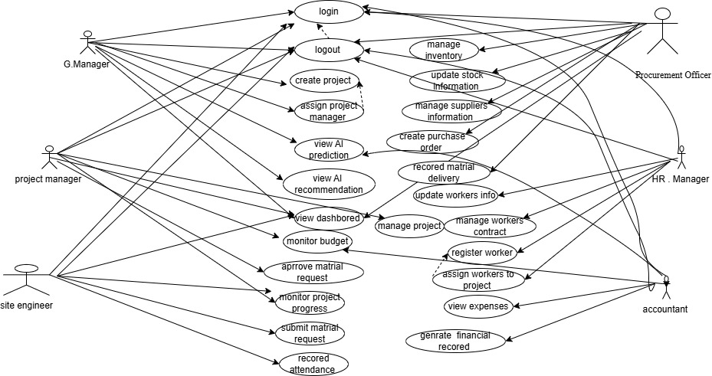
Figure 5.1 use case diagram

5.1.3 Use Case Description
Use Case Description Overview
The Use Case Description defines detailed interactions between system actors and the AI-Integrated Construction Project Management System. Each use case explains how a specific function is performed, including the actor, preconditions, main flow, and expected outcome.
The system supports six main actors:
- General Manager
- Project Manager
- HR Manager
- Site Engineer
- Procurement Officer (Store Keeper)
- Accountant
Each actor performs specific system operations based on their role, ensuring proper separation of responsibilities and efficient workflow across project management, workforce management, material handling, procurement, finance, and AI-based decision support.
All use cases are triggered after successful authentication (Login), and most operations depend on role-based access control.
Key Use Case Descriptions Summary
- Project & Resource Management
- The General Manager creates projects and assigns Project Managers.
- The Project Manager manages project execution and monitors progress.
- The HR Manager registers workers and assigns them to projects.
- The Site Engineer records attendance and updates project progress.
- Material & Procurement Management
- The Site Engineer submits material requests.
- The Project Manager approves material requests.
- The Procurement Officer manages inventory, suppliers, purchase orders, and material deliveries.
- Finance Management
The Accountant monitors expenses, budget utilization, and generates financial reports.
Financial data is automatically updated from procurement and workforce activities.
AI & Reporting
The system generates AI-based predictions and recommendations using project, cost, and workforce data.
The General Manager and Accountant view dashboards, AI insights, and reports for decision-making.
Key Use Case Flow Example
Register Worker → Assign Worker → Record Attendance
Submit Material Request → Approve Request → Update Inventory
Create Project → Assign PM → Manage Project → Monitor Progress
Expenses → Budget Monitoring → Financial Reports → AI Insights

5.1.4 Object Modeling
Object modeling defines the main entities (objects) of the Construction Management System, their attributes, and relationships. It provides a conceptual view of how the system is structured, including users, projects, materials, workers, and financial operations (Finance & Accounting).

5.1.4.1 Data Dictionary
User
- user_id (PK): Unique identifier for system users
- full_name: Full name of user
- email: Login email
- password: Encrypted password
- role: System role (Admin, Project Manager, Finance Officer, Accountant, Store Keeper)
- phone: Contact number
Project
- project_id (PK): Unique project ID
- project_name: Name of project
- location: Project location
- start_date: Start date
- end_date: Expected completion date
- budget: Total allocated budget
- status: Project status (Active, Pending, Completed)
Material
- material_id (PK): Material ID
- name: Material name
- quantity: Available stock
- unit_price: Price per unit
- supplier: Supplier information
- project_id (FK): Related project
Worker
- worker_id (PK): Worker ID
- name: Full name
- skill: Work type (mason, electrician, etc.)
- daily_wage: Payment per day
- project_id (FK): Assigned project
Finance
- finance_id (PK): Finance record ID
- project_id (FK): Related project
- total_budget: Approved budget
- total_expense: Total spent amount
- remaining_balance: Remaining budget
- recorded_date: Date of record update
- recorded_by (FK → User): Finance Officer user ID
Account (Accounting Records)
- account_id (PK): Account record ID
- project_id (FK): Related project
- income: Total income recorded
- expense: Total expenses recorded
- balance: Current balance
- transaction_type: Income / Expense
- recorded_by (FK → User): Accountant user ID
- date: Transaction date

5.1.4.2 Analysis Level Class Diagram (Conceptual Modeling)
The system is modeled using the following conceptual classes:
User (Central Class)
- user_id
- full_name
- email
- password
- role
Roles include:
- General manager
- Project Manager
- Finance Officer
- Accountant
- Site engineer
- Store Keeper
Project
- project_id
- project_name
- location
- budget
- status
Material
- material_id
- name
- quantity
- unit_price
- Worker
- worker_id
- name
- skill
- daily_wage
Finance
- finance_id
- total_budget
- total_expense
- remaining_balance
Account (Accounting Records)
- account_id
- income
- expense
- balance
Relationships (Conceptual View)
User → Project: One user (Project Manager) manages multiple projects
Project → Worker: One project has many workers
Project → Material: One project uses many materials
Project → Finance: One project has one finance record
Project → Account: One project has multiple accounting transactions
User (Finance Officer) updates finance records
User (Accountant) records financial transactions (not a separate entity, only role-based user)

5.2 Dynamic Modeling

5.2.1 Sequence Diagrams
Sequence diagrams are a type of UML behavioral modeling used to represent the dynamic interaction between actors and system components over time. They show how different objects in the system communicate with each other to perform specific functions, highlighting the order of messages exchanged.
In the Construction Management System, sequence diagrams are used to model the step-by-step processes of key system operations such as project creation, material management, worker assignment, and financial transactions. Each diagram illustrates how a user interacts with the system through the frontend, how requests are processed by the backend server, and how data is stored or retrieved from the database.
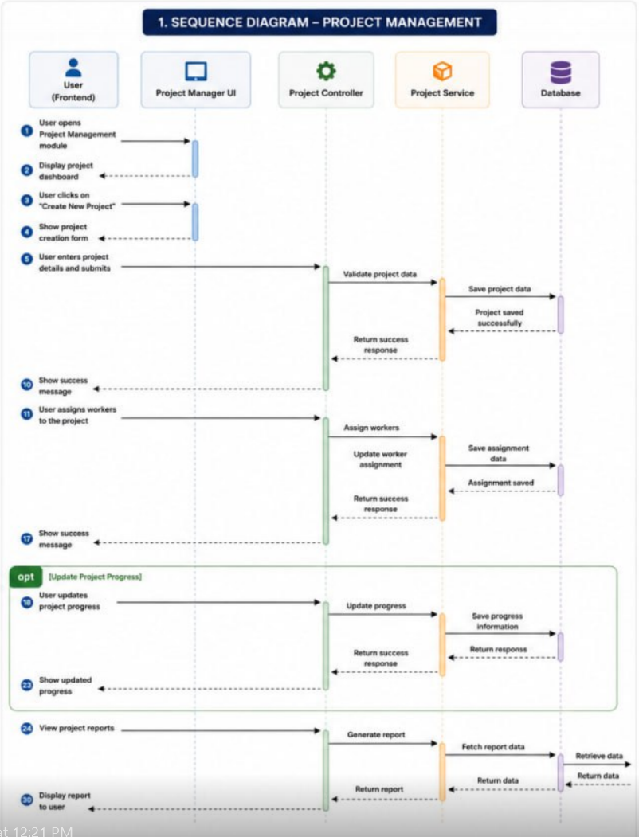
Figure 5.2 sequence diagram for project management

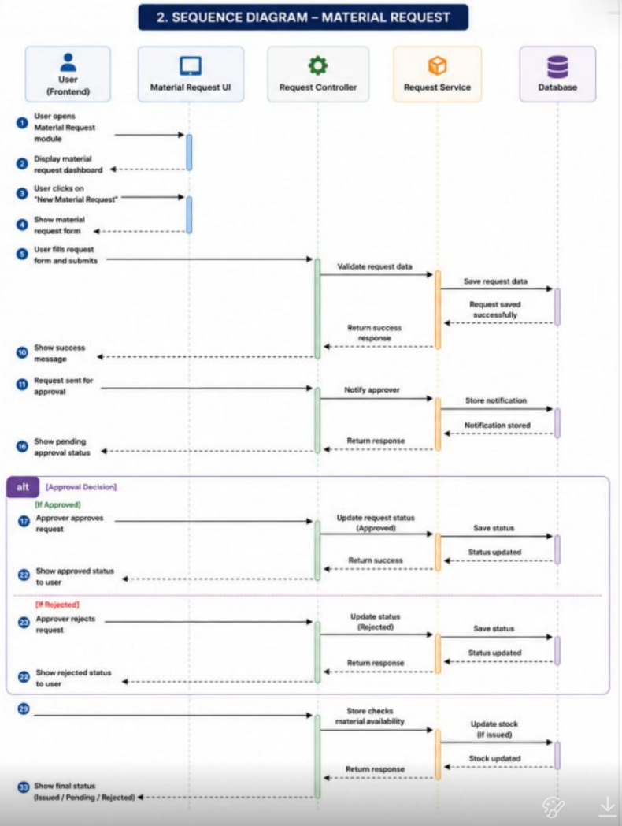
Figure 5.3 sequence diagram for matrial request

5.2.2 Activity Diagrams
Activity diagrams are a type of UML behavioral modeling used to represent the workflow or step-by-step activities of a system process. They describe how different actions are performed in a system from start to finish, including decisions, parallel processes, and control flow.
In the Construction Management System, activity diagrams are used to show how tasks such as project creation, material management, worker assignment, finance handling, and reporting are executed in a structured workflow. Unlike sequence diagrams that focus on object interactions, activity diagrams focus on the overall process flow of activities.

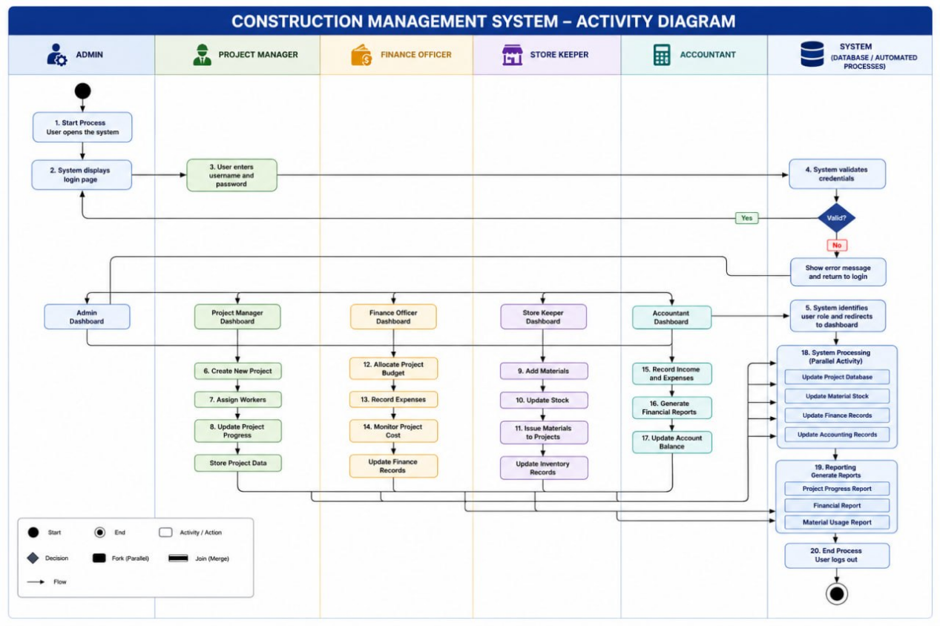
Figure 5.4 activity diagram
5.2.3 State Diagrams
State Diagrams are used to model the various states an object passes through during its lifecycle within the system. They illustrate how an object changes from one state to another in response to specific events or actions. In the proposed AI-Integrated Construction Project Management System, state diagrams are used to represent the lifecycle of important entities such as projects and material requests. These diagrams help in understanding system behavior, status transitions, and process flow throughout different stages of operation.
Included State Diagrams:Project Lifecycle State Diagram
Material Request Lifecycle State Diagram
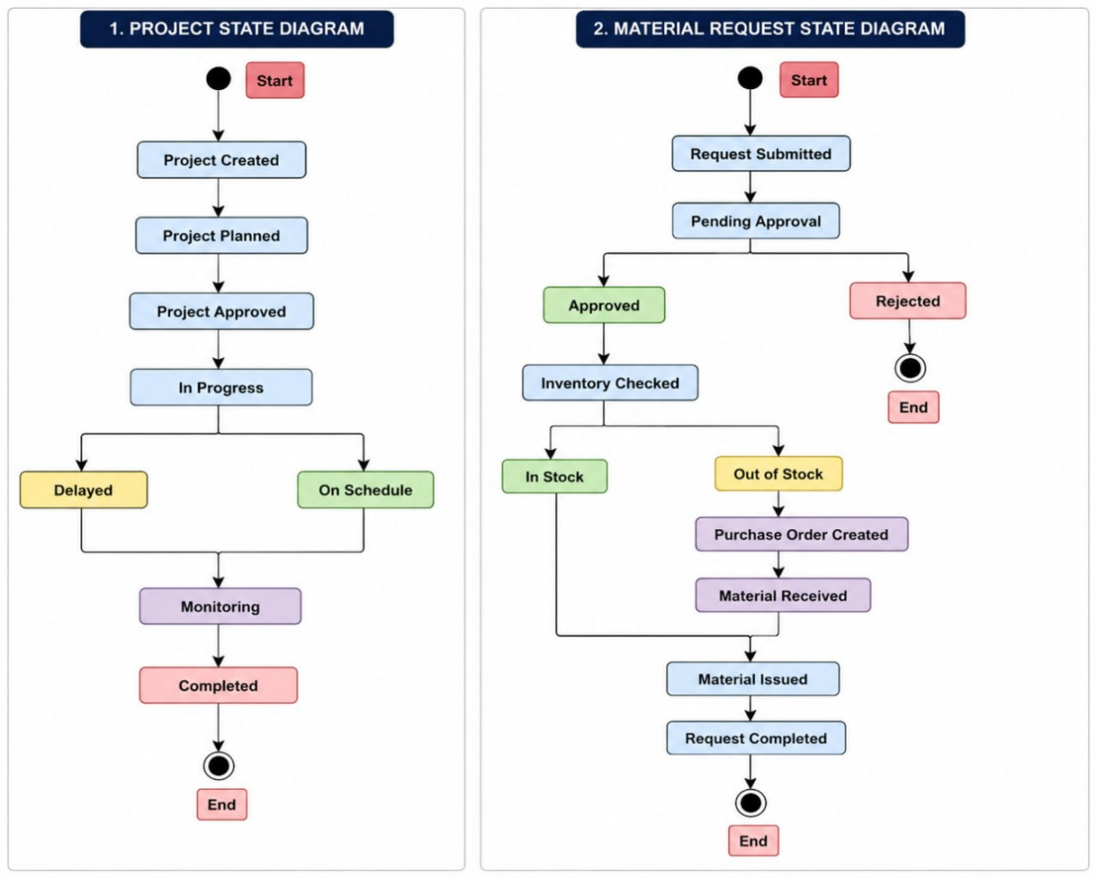
Figure 5.5 state diagram
5.2.4 User Interface
The User Interface (UI) represents the visual interaction between users and the proposed AI-Integrated Construction Project Management System. The interface is designed to provide a simple, user-friendly, and efficient environment that enables users to perform their tasks effectively. The system provides role-based interfaces for different users, including the General Manager, Project Manager, HR Manager, Site Engineer, Procurement Officer, and Accountant.
The major interfaces identified for the system are described below.
Home Page Interface
The Home Page serves as the entry point to the system. It provides information about the construction company, system services, and navigation options for users. The interface is designed to present a professional overview of the organization and allow users to access the login page.
Login Interface
The Login Interface allows authorized users to access the system by entering valid credentials. It ensures secure authentication and redirects users to their respective dashboards based on their roles.
Dashboard Interface
The Dashboard Interface provides an overview of system activities and important information. It displays project summaries, workforce information, material status, financial information, and AI-generated insights to support decision-making and monitoring.
Project Management Interface
The Project Management Interface allows users to create, manage, and monitor construction projects. It provides access to project details, progress updates, resource allocation, and project status information.
Worker Management Interface
The Worker Management Interface enables the registration, assignment, and management of workers. It supports workforce tracking, attendance recording, and worker information management.
Material Management Interface
The Material Management Interface supports material requests, inventory monitoring, stock updates, and material allocation. It helps ensure proper management of construction resources.
Finance Management Interface
The Finance Management Interface provides access to expense monitoring, budget utilization, and financial reporting functions. It assists management in tracking project costs and financial performance.
AI Analytics Interface
The AI Analytics Interface presents project predictions, cost analysis, delay forecasts, and decision-support recommendations. It assists managers in making informed decisions based on system-generated insights.
5.2.5 Supplementary Specifications
Overview
Supplementary Specifications describe additional system requirements that are not fully represented in use cases, sequence diagrams, activity diagrams, or other UML models. These specifications define important quality attributes, constraints, and operational requirements of the proposed AI-Integrated Construction Project Management System.
Security Requirements
The system shall provide role-based access control for all users.
Users must authenticate using valid credentials before accessing system functions.
Sensitive data shall be protected from unauthorized access.
Performance Requirements
The system shall provide fast response times for user requests.
Project, workforce, material, and financial information shall be updated in real time.
Reports shall be generated efficiently with minimal processing delay.
Reliability Requirements
The system shall ensure accurate storage and retrieval of project data.
Regular database backup mechanisms shall be supported.
The system shall maintain data consistency across all modules.
Usability Requirements
The user interface shall be simple, intuitive, and easy to navigate.
The system shall provide a consistent user experience across all modules.
Users shall be able to perform tasks with minimal training.
AI and Decision Support Requirements
The system shall analyze project data to generate cost predictions.
The system shall predict potential project delays.
The system shall provide recommendations to support management decision-making.
Conclusion
These supplementary specifications ensure that the proposed system is secure, reliable, user-friendly, efficient, and capable of supporting effective construction project management and decision-making processes.

CHAPTER 6 SYSTEM DESIGN

6.1 Introduction
System design is the process of converting system requirements into a structured blueprint for implementation. It defines the system architecture, components, database structure, interfaces, and integration methods. The main purpose of this chapter is to present the design of the AI-Integrated Construction Project and Resource Management System.
The system is designed to integrate key construction management functions such as project management, workforce management, material management, procurement, and financial management into a single platform. It also includes an Artificial Intelligence module that supports decision-making through predictions such as cost estimation, delay prediction, and resource optimization. The design ensures the system is scalable, secure, reliable, and easy to maintain.

6.2 System Architecture Design
The proposed system follows a Three-Tier Architecture, which includes Presentation Layer, Application Layer, and Data Layer. An AI module is also integrated into the application layer to provide intelligent analysis and predictions.
1. Presentation Layer
This layer is the user interface of the system. It allows users to interact with the system through dashboards and forms. It includes modules such as project management, workforce tracking, material management, procurement, financial management, and reporting.
Technologies Used: React.js, Tailwind CSS, JavaScript
2. Application Layer
This layer contains the business logic of the system. It processes user requests, manages data operations, and applies business rules. It handles user management, project planning, inventory control, procurement, budgeting, and report generation. It also communicates with the AI module for predictions.
Technologies Used: Node.js (Express) or Laravel, REST APIs
3. Artificial Intelligence Module
The AI module provides intelligent decision support by analyzing project data. It performs cost prediction, delay prediction, workforce optimization, and performance evaluation. It communicates with the application layer using APIs.
Technologies Used: Python, Scikit-learn, Pandas, NumPy
4. Data Layer
This layer stores all system data such as users, projects, workers, materials, suppliers, financial records, and AI datasets. It ensures secure and efficient data storage and retrieval.
Technology Used: Postgresql
System Architecture Diagram
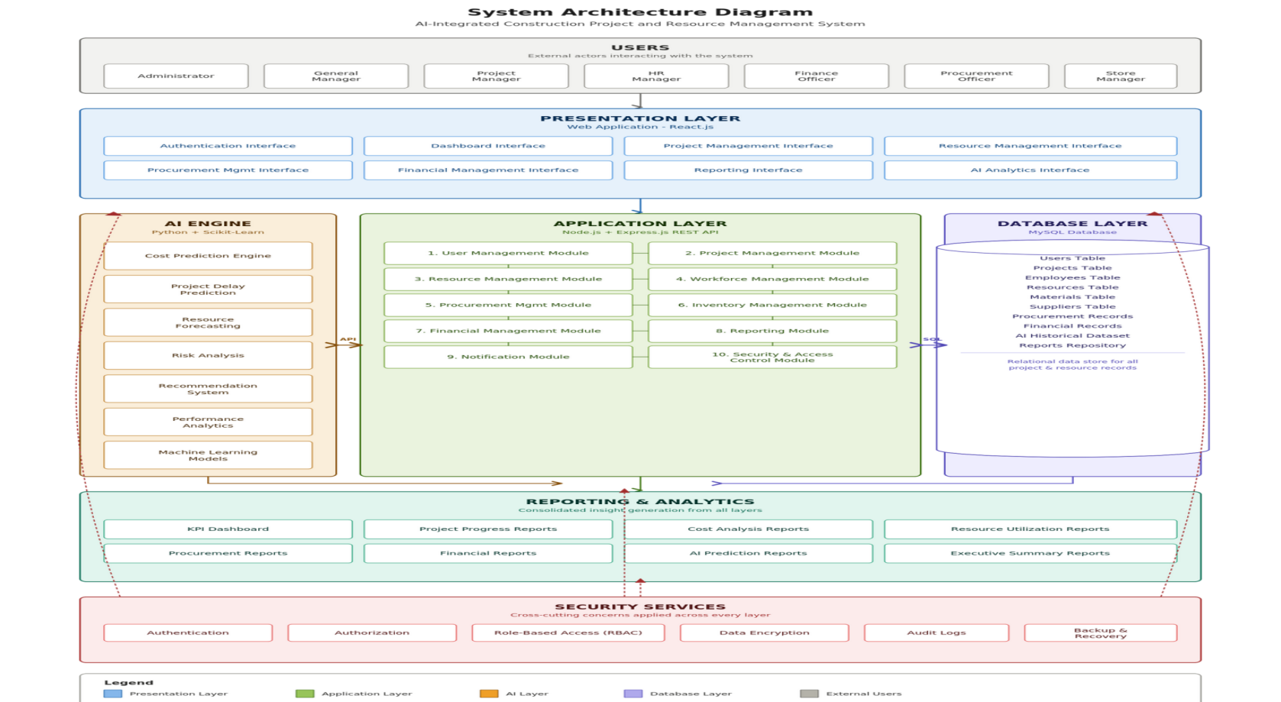
Figure 6.1 archtecture diagram

6.3 Database Design
The database stores key information such as users, projects, employees, materials, suppliers, procurement, financial records, and AI predictions. Relationships between tables are defined using primary and foreign keys to maintain data integrity and reduce redundancy.

6.3.1 Database Entities
Main entities include:
- User: user details (ID, name, login, role)
- Project: project information (name, budget, status)
- Employee: worker details and project assignment
- Material: material stock and supplier info
- Supplier: supplier contact and details
- Procurement: purchase records
- FinancialRecord: project financial transactions
- AI_Prediction: AI outputs like cost and delay predictions

6.3.2 Entity Relationship Diagram (ERD)
Relationship Description:
- One Project can have many Employees.
- One Project can have many Financial Records.
- One Supplier can provide many Materials.
- One Material can appear in many Procurement Records.
- One Project can have many AI Predictions.
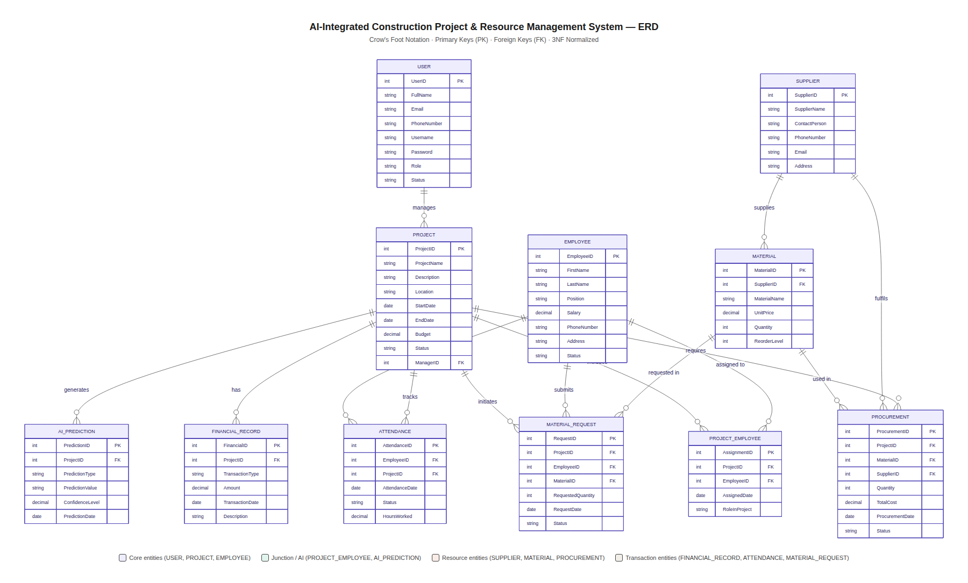
Figure 6.2 ER diagram

6.4 User Interface Design
User Interface (UI) Design represents the visual layout and interaction screens through which users access and utilize system functionalities. The objective of the user interface design is to provide a simple, user-friendly, and efficient environment that enables users to perform their tasks effectively. The proposed AI-Integrated Construction Project Management System provides role-based interfaces for different users, including General Managers, Project Managers, HR Managers, Site Engineers, Procurement Officers, and Accountants. The interface designs focus on usability, accessibility, consistency, and efficient navigation across system modules.
Included User Interface Designs:
Home Page Interface
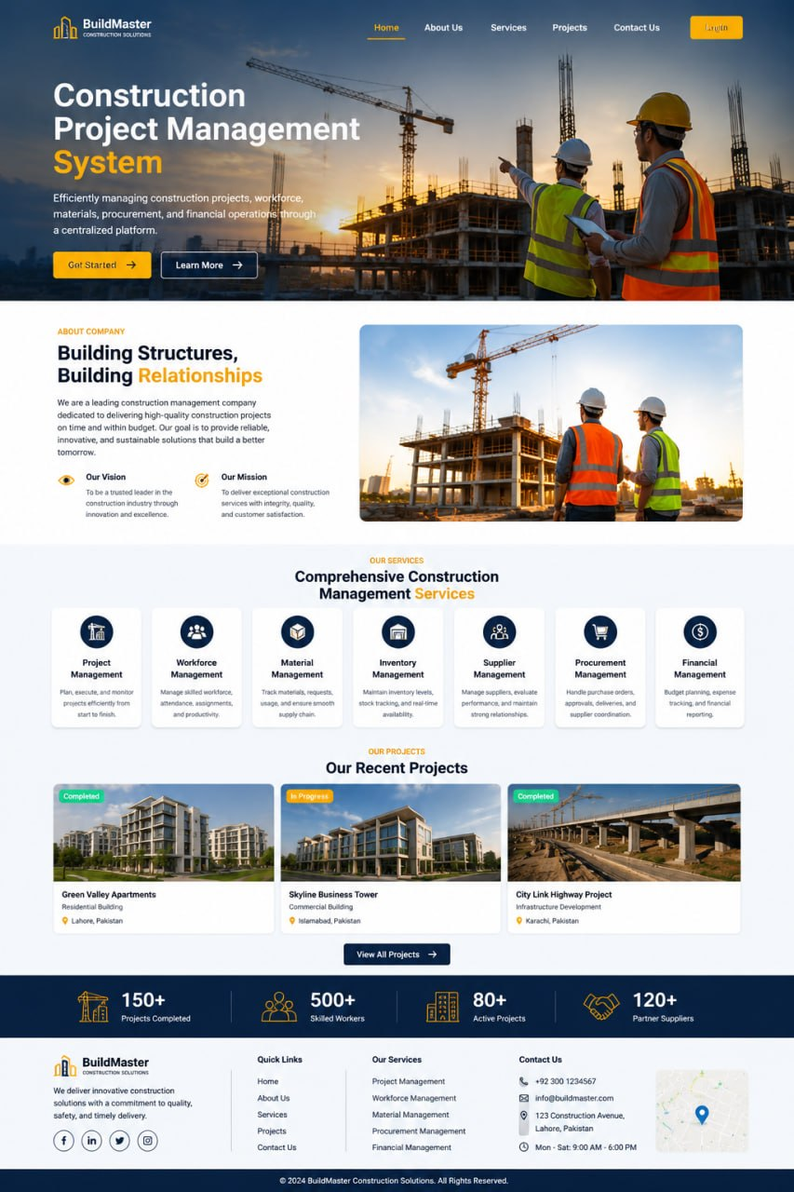
Figure 6.3 home user interface

Admin Dashboard Interface

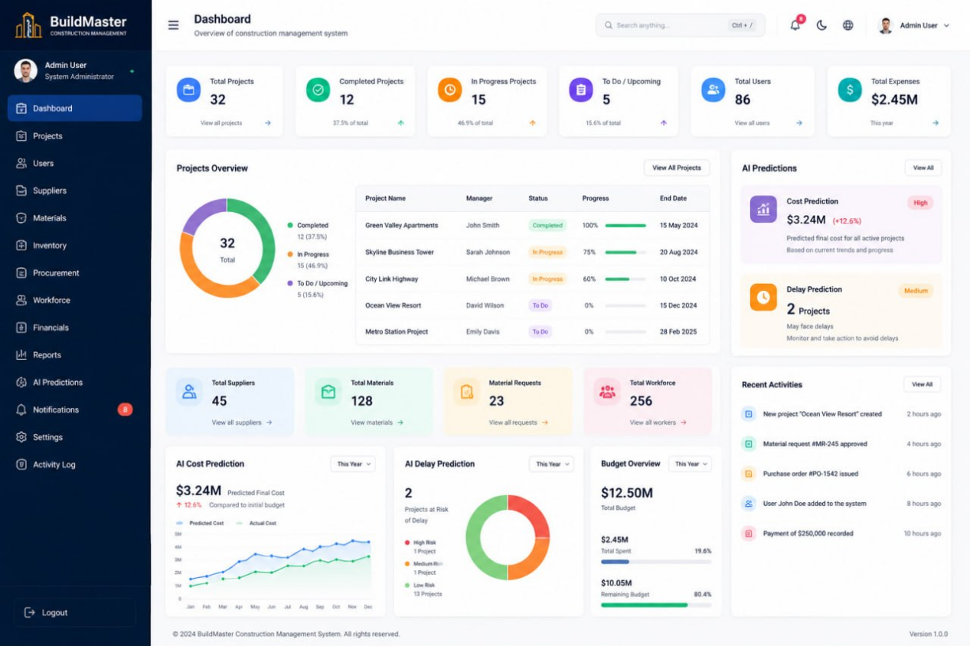
Figure 6.4 admin dashboard interface

6.5 Component Design
Component design defines the main modules of the system and their responsibilities. Each component performs a specific function and works together with others to ensure smooth system operation.
The User Management Component handles user accounts, authentication, authorization, and role-based access control to ensure secure access to the system. The Project Management Component manages project creation, scheduling, progress tracking, budget control, and status monitoring.
The Resource Management Component is responsible for managing materials, equipment, and workforce allocation to improve resource utilization. The Procurement Management Component manages supplier information, purchase requests, procurement transactions, and delivery tracking.
The Financial Management Component tracks project expenses, monitors budgets, and generates financial reports for cost control. The AI Prediction Component analyzes historical data to predict costs, delays, resource needs, and project risks to support decision-making. The Reporting Component generates project, financial, resource, and AI-based reports for performance monitoring.
Overall, the system is divided into independent modules to improve scalability, maintainability, and performance. These components work together to achieve the objectives of the AI-Integrated Construction Project and Resource Management System.

6.6 Class and Object Design

6.6.1 Introduction
Class and Object Design defines the structure of the system in terms of classes, attributes, methods, and relationships. It provides a blueprint for implementing the object-oriented design of the AI-Integrated Construction Project and Resource Management System. This design improves molecularity, re-usability, and maintainability of the system

6.6.2 Major Classes
User Class
- Attributes: UserID, FullName, Email, Username, Password, Role
- Methods: Login(), Logout(), UpdateProfile()
Project Class
- Attributes: ProjectID, ProjectName, StartDate, EndDate, Budget, Status
- Methods: CreateProject(), UpdateProject(), DeleteProject(), TrackProgress()
Employee Class
- Attributes: EmployeeID, FirstName, LastName, Position, Salary
- Methods: AddEmployee(), UpdateEmployee(), AssignProject()
Material Class
- Attributes: MaterialID, MaterialName, Quantity, UnitPrice
- Methods: AddMaterial(), UpdateStock(), CheckAvailability()
Procurement Class
- Attributes: ProcurementID, SupplierID, Quantity, TotalCost
- Methods: CreateOrder(), UpdateOrder(), GenerateReceipt()
AI_Prediction Class
- Attributes: PredictionID, PredictionType, PredictionValue, ConfidenceLevel
- Methods: PredictCost(), PredictDelay(), GenerateRecommendation()

6.6.3 Class Relationships
The classes interact as follows:
- A User manages one or more Projects.
- A Project contains multiple Employees.
- A Project utilizes multiple Materials.
- Procurement manages the acquisition of Materials from Suppliers.
- AI_Prediction analyzes Project data and generates predictions.
Class Diagram:
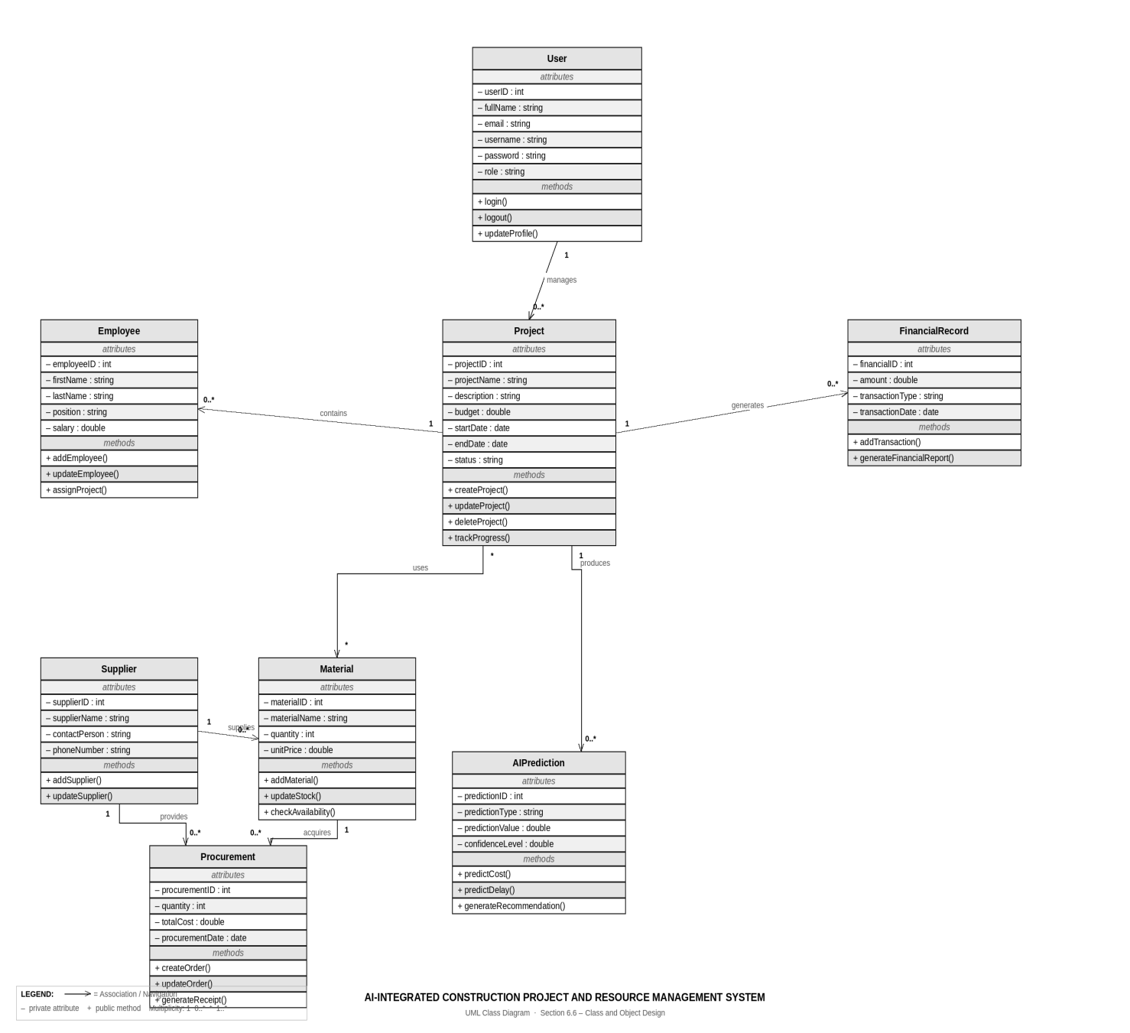
Figure 6.5 class diagram

6.7 Security Design

6.7.1 Introduction
Security design protects system data, users, and resources from unauthorized access, modification, and loss. The proposed AI-Integrated Construction Project and Resource Management System ensures data confidentiality, integrity, and availability through multiple security mechanisms.

6.7.2 Authentication
Authentication verifies user identity before system access. It includes username and password login, password encryption, secure session management, and logout functionality. Only registered users can access the system.

6.7.3 Authorization
Authorization controls user permissions using Role-Based Access Control (RBAC). Each user can only access authorized functions based on their role:
- Admin: Full system access
- Project Manager: Manage projects and employees
- HR Manager: Manage employee records
- Procurement Officer: Handle procurement activities
- Finance Officer: Manage financial records
- Store Manager: Manage materials and inventory

6.7.4 Data Security
Data security is ensured through password hashing, input validation, data encryption, secure database access, and protection against SQL injection. These measures maintain system safety and data integrity.

6.7.5 Backup and Recovery
The system supports regular database backups, recovery procedures, and data restoration to prevent data loss and ensure business continuity.

6.7.6 Audit and Monitoring
The system records user activities such as login, data creation, modification, deletion, and administration actions. These logs help detect unauthorized access and support system monitoring.

6.8 System Integration Design
System integration design defines how different modules of the AI-Integrated Construction Project and Resource Management System interact and communicate. It ensures smooth data flow, consistency, and coordination among all components for efficient system operation.
The system consists of several interconnected modules that work together to achieve full project and resource management functionality.
The User Management Module controls authentication, authorization, and role-based access for all system modules. The Project Management Module interacts with employee, financial, resource, and AI modules to monitor project progress and performance.
The Resource Management Module communicates with procurement and inventory functions to manage material availability and allocation. The Procurement Module integrates with supplier and material management to support purchasing and stock control.
The Financial Management Module receives data from project and procurement activities to manage expenses and generate financial reports. The AI Prediction Module uses historical data from the database to predict costs, delays, resource needs, and risks.
The Reporting Module collects data from all modules to generate comprehensive reports for decision-making and performance evaluation.
The system follows the following integration flow:
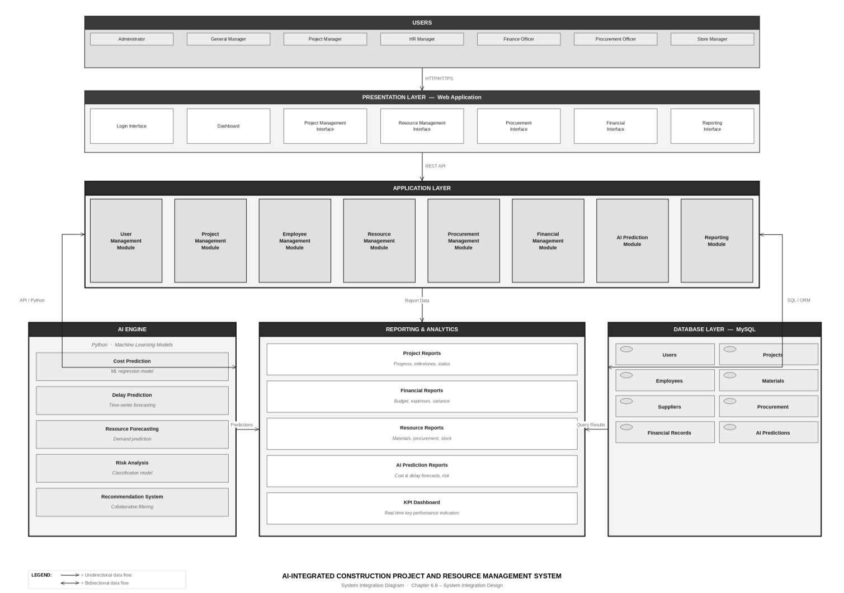

Figure 6.6 Integration diagram

References
- Bourque, P., & Fairley, R. E. (2014). Guide to the Software Engineering Body of Knowledge (SWEBOK V3.0). IEEE Computer Society.
- Dennis, A., Wixom, B. H., & Tegarden, D. (2020). Systems Analysis and Design: An Object-Oriented Approach with UML (6th ed.). Wiley.
- Elmasri, R., & Navathe, S. B. (2017). Fundamentals of Database Systems (7th ed.). Pearson.
- Fowler, M. (2003). UML Distilled: A Brief Guide to the Standard Object Modeling Language (3rd ed.). Addison-Wesley.
- Kerzner, H. (2022). Project Management: A Systems Approach to Planning, Scheduling, and Controlling (13th ed.). Wiley.
- Project Management Institute (PMI). (2021). A Guide to the Project Management Body of Knowledge (PMBOK® Guide) (7th ed.). Project Management Institute.
- Pressman, R. S., & Maxim, B. R. (2020). Software Engineering: A Practitioner's Approach (9th ed.). McGraw-Hill Education.
- Sommerville, I. (2020). Software Engineering (10th ed.). Pearson.
Online References
- Project Management Institute. (2024). Project Management Resources. Retrieved from https://www.pmi.org
- World Bank. (2024). Infrastructure and Construction Sector Reports. Retrieved from https://www.worldbank.org
- Engineering News-Record. (2024). Construction Industry Management Resources. Retrieved from https://www.enr.com
- Microsoft Learn. (2024). Systems Analysis and Software Development Fundamentals. Retrieved from https://learn.microsoft.com

Students whose names are listed below declare that this project, entitled "AI-Integrated Construction Project and Resource Management System," is our original work, conducted as part of the requirements for the award of the degree of Bachelor of Science in computer science in the computer science at Debre Berhan University.
We affirm that this work has not been submitted previously, in whole or in part, to any other institution for the award of any degree or diploma. All sources of information used in this work have been acknowledged, and proper citations have been provided where necessary.
We understand that plagiarism or any form of academic dishonesty violates Debre Berhan University's academic policies and may result in disciplinary action.
Student Information:

Name id signature
- Getahun Fikade ……………..…1501222 …………….
- Fikadu Asafaw…………………1501633 ……………..
- Temesgen Birhanu………………1501496 …………….
- Abel Negash …………………….1404936 ……………..

Advisor’s Declaration
Metadel .A, confirm that I have reviewed the above project work and found it to be in accordance with the academic standards of Debre Berhan University.

Advisor’s Name: ______________________ Signature ________ Date ______

